## horizontal line



**Technology Strategy Research Project :** **Digital** **Transformation Strategy for GameStop Corp.**

**TEAM 3**

MARCH 3, 2021

**By Naina Grover, Harry Horowitz, Mingxin Li, Weiwen Qi, Jing Dai, Haocong Ding**

# Overview

The Video Games industry is approaching a major turning point with the upcoming release of next-generation gaming consoles, expected for fall 2020. The next major console offerings from Microsoft (9.8% industry market share) and Sony (4.5% industry market share) will incorporate streaming functionality, will likely both offer subscription services (confirmed by Microsoft, rumored for Sony), while also throwing a lifeline to the physical gaming format by once again including a Blu-ray disc drive.

# Goals

* Analyze the Video-Gaming industry in which GameStop operates
* Prepare its Digital Business Transformation plan.

This analysis will explain the possible ways in which there could be digital disruption.

# Introduction

Introduction of GameStop

Based in Texas, GameStop is a [video game](https://en.wikipedia.org/wiki/Video_game), consumer electronics, and gaming merchandise retailer. GME was founded in Dallas in 1984 with the name of Babbage's and renamed GameStop in 1999. As of Feb 1, 2020, GME owns over 5500 retail stores throughout the United States, Europe, Canada, Australia, and New Zealand.

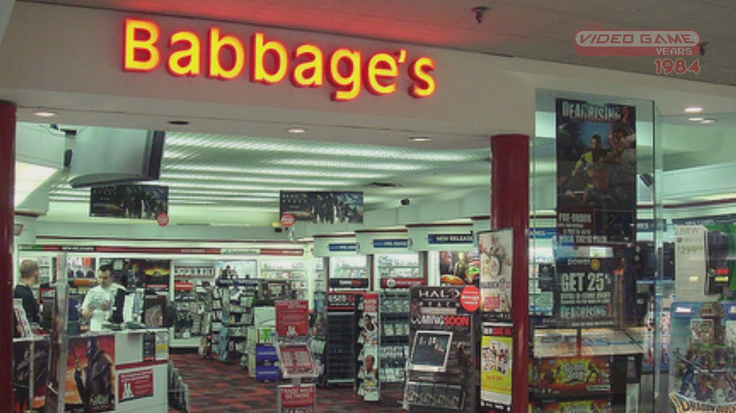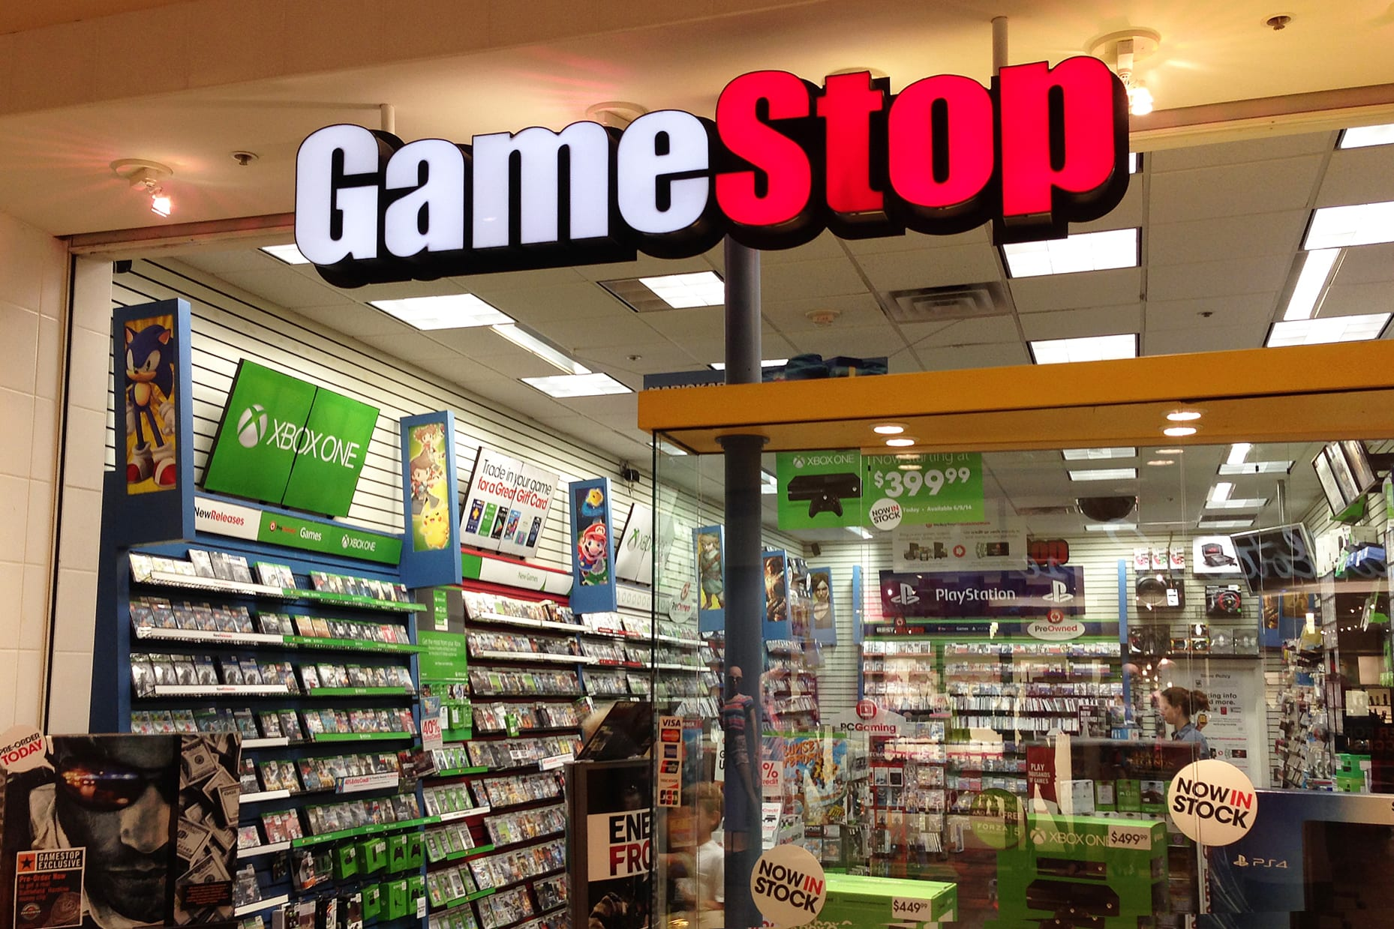

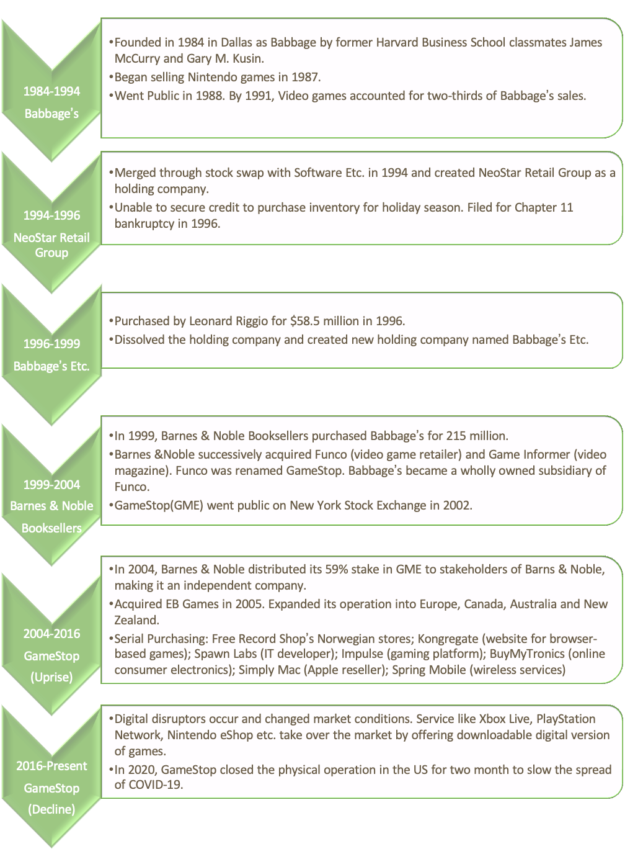

Competition

The video game industry is highly competitive and is affected by rapid changes in consumer preferences and frequent new product launches.

In the U.S., GameStop competes with mass merchants and regional chains like Wal-Mart Stores, Inc.; Target Corporation; Amazon.com, Inc.; and Best Buy Co., Inc.

Sony (PlayStation Network), Microsoft (Xbox Live), Nintendo (Nintendo Switch Online), and other online platforms operated by other online retailers and game rental companies began to distribute games through digital download.

The current consoles of Sony, Nintendo, and Microsoft promote the development of download technology. Besides, Microsoft also sells a CD-free console that is currently available to consumers.

Consumers’ preference for downloading video game content continues to increase. These consoles and other technological advancements continue to expand customers' access and download video games through digital distribution. GameStop customers may no longer choose to buy video games in its store or reduce their purchases of physical forms of games. Therefore, GameStop's business and operating results may be negatively affected.

**GameStop’s Current Business Model**

Consumer Segmentation

GameStop(GME) has a mass-market business model. It does not significantly distinguish between customer segments. The company targets everyone who seeks video games and tech products.

Value Proposition

GameStop offers four main value propositions: accessibility, convenience, innovation, and brand/status. GME provides accessibility by making its location easily accessible. Its stores are usually located in busy shopping malls, open-air centers, and pedestrian spaces in major metropolitan areas. The company also creates accessibility by offering multiple options. It has acquired many other gaming and technology companies in its history, including EB Games, Rhino Video Games, Micromania, Jolt Online Gaming, Spawn Labs, Impulse, BuyMyTronics, and Spring Mobile. These purchases help to diversify its investment portfolio and greatly expand its capabilities.

GME provides convenience by making customers' lives easier. Its trading plan enables consumers to trade in electronic game software/hardware, tablets, and smartphones that they no longer use or play. Customers will receive trade credits for the purchase of new products.

Innovation is part of GME’s culture. It operates GameStop Technology Institute (GTI), a business unit dedicated to establishing partnerships with academic institutions and top technology companies to explore and deliver innovative technologies and business solutions. Specifically, partners share resources and collaborate on research and development.

GME has established a strong brand because of its successful operation. It is the world's largest omnichannel video game retailer, the largest AT&T authorized distributor, the largest Apple certified product distributor, and the owner of the world's largest seller of popular culture-themed products. It has more than 5,000 stores in 14 countries and more than 40,000 employees. Finally, it owns the "Game Informer" magazine, the world's leading print and digital electronic game publication.

Channel

GameStop's primary channel is retail stores throughout the United States, Canada, Australia, and Europe. It also sells products through its main website and various specific brand websites. The company promotes its products through in-store marketing efforts such as its website, social media pages, TV/online/radio advertisements, loyalty programs, and catalogs.

**Digital disruption in the video gaming industry**

A set of digital disruption trends have emerged in the video gaming industry:

Physical VS Digital

For a long time, GameStop sold physical copies of games like CDs or cartridges and received one-time revenue from those sales.Before 2017, GameStop's distribution model relied on its network of 7000 traditional brick-and-mortar physical retail storefronts and 20000 sales associates.

Nowadays, game selling is more like a service provided, and digital distribution is becoming the bridge between technology platforms and personalized gaming experiences. Consumers can purchase games via digital downloads or streaming directly from game console publishers such as Xbox, EA, and Playstation. Gamers no longer need to go to a physical store.

Some convenient digital offerings are like:

| **Company** | **Service** | **Price per month** | **Offerings** |
| --- | --- | --- | --- |
| Xbox | Xbox Game Pass | $10.95 | Access to more than 100 Xbox One and Xbox 360 games |
| EA | EA Access | $4.95 | 1. Access to the EA ‘Vault’ which comprises over 45 popular EA titles 2. Early access benefits 3. Discounts on game purchases |
| Playstation | Playstation Plus | $9.99 | Access to Sony’s online marketplace |

Disruption happens as online distributors augment their power with growing reach and influence on consumer purchasing behavior.

Individual Gaming VS Social Gaming

A decade ago, gamers would mostly play games by themselves and sometimes with friends nearby, while today, massively multiplayer online games are allowed. In reality, titles with significant social features in nature are the most popular ones today, presenting powerful network effects. Publishers must acquire social media capabilities to build connections among gamers.

PC & Console VS Mobile

Digital disruption occurs when a new business like mobile gaming has exploded, but PC and console growth has cut down to the low single digits at the same time. Traditional game publishers need to build capabilities in the new business because the type of game that flourishes on PC and console is very different from the one that works well on mobile.

Live Services Thrive

With the thrive of platforms such as YouNow, Periscope, YouTube Gaming, and Twitch, reality live shows dominate broadcast TV and digital channels. Gamers like to watch the adventures, opinions, product reviews, creations, and failures of others. In a word, gamers start to entertain gamers.

**Digital disruptors in the industry**

Electronic Arts (EA) is an American [video game company](https://en.wikipedia.org/wiki/Video_game_company) headquartered in [California](https://en.wikipedia.org/wiki/California). EA develops and publishes games of established franchises.

PlayStation is a Japanese video game brand produced by Sony Interactive Entertainment. The PlayStation Store is an online virtual market, offering a range of [downloadable content](https://en.wikipedia.org/wiki/Downloadable_content) both for purchase and available free of charge.

Steam is Valve’s video game digital distribution service. Currently, Steam is the largest digital distribution platform for PC gaming. By 2019, Steam had over 34,000 games with more than 95 million monthly active users.

[Xbox Live](https://en.wikipedia.org/wiki/Xbox_Live) is an online service provided by Microsoft. The [Xbox Live Marketplace](https://en.wikipedia.org/wiki/Xbox_Live_Marketplace) allows the purchase and download of games and various forms of multimedia.

**The sources of digital disruption**

* New digital innovations in product or service delivery
* Mobile and social media channels, although personalized marketing using data and analytics, are also sources referenced.
* The emergence of IT, AI, and machine learning

**Digital Disruptors Prevailing Business Model**

As mentioned above, the gaming retailer industry's main digital disruptors are Sony and Microsoft. Their prevailing business model is the typical “razor and blades” business model. In this model, companies sell the core equipment at a relatively low price and make money by selling the related product in the following consumption process.

For the gaming retailer industry, Sony and Microsoft typically sell their consoles – PlayStation and Xbox – at a low price to attract consumers. Then customers need to buy physical copies of the games to start playing. Physical games' profit is usually large enough to cover the cost rising from the console's sale.

This “razor and blades” model has proved to be successful during the past decades. When customers buy the console from one company, they automatically have brand loyalty. However, this model is not a guarantee of the regular customer. If the customers find that the value provided by this company is lower than the switching cost, they will not hesitate to do so.

**Difference between the present model and prevailing model**

In the past, Sony and Microsoft both adopted the typical “razor and blades” model, and their profit mainly generated from a one-time revenue opportunity for the publisher as gamers would purchase the game, play through the content, and then repeat the purchasing cycle as they moved on to a different game. Now, the sale of video games is still the main profit point, but the companies change how they charge the fee.

1. The copies of the games vary from physical version to digital version.
2. The games contain more in-game purchases and downloadable content (DLC).
3. The customers can choose between subscription and buyout.

Digital Version

As we can see from the chart below, the market share of digital versions of video games has surpassed that of the physical version. Customers have a reason to do so.

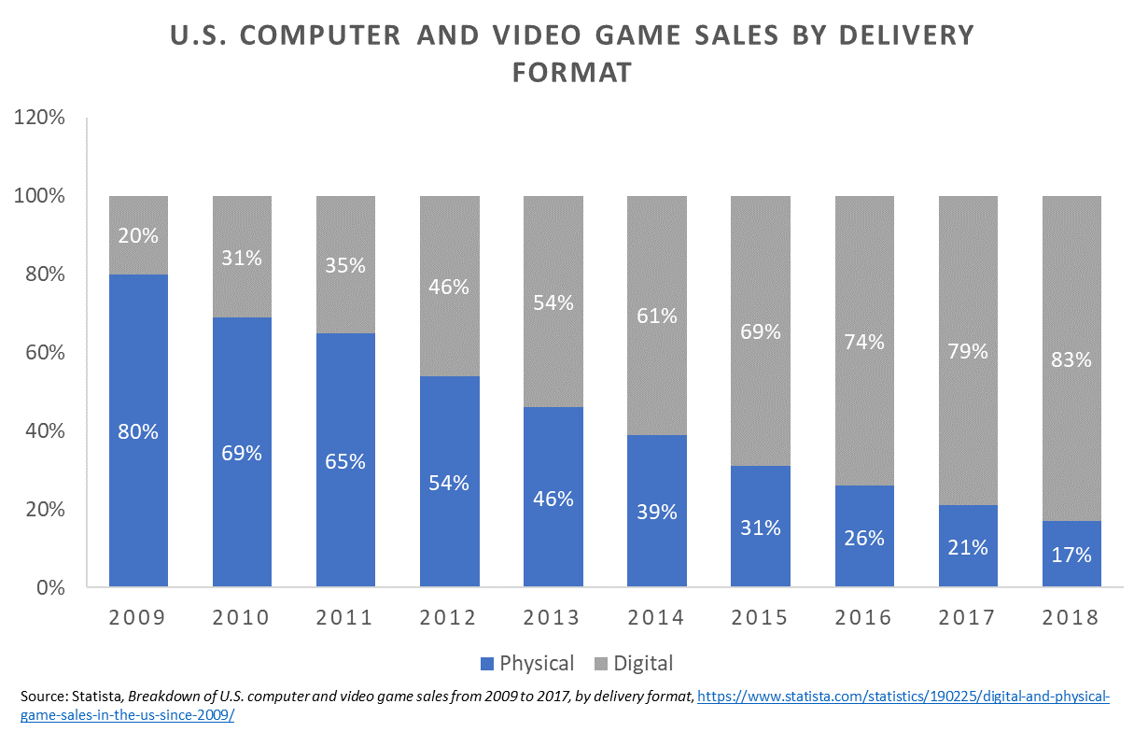

First, the digital version is more comfortable for customers to purchase. They do not need to stay up late or wait on snow days to buy the games they fancy. They can take a nice sleep, wake up in the morning and have a nice day starting with the games. Second, there are no purchase restrictions for digital copies. If a game is popular, the customer might need to wait for the physical version to be produced due to the limited productivity. Besides, the companies can sell the games at a lower price but with a higher profit margin since the digital version's cost is obviously lower compared to that of the physical version.

In-game purchase and DLC

This strategy can also be considered a similar strategy with “razor and blades” but also at the product level. With in-game purchases and DLC, the company can provide a lower price to attract more customers than before. Even if the purchase in the game is optional, most customers will still buy it to improve their experience. This mechanism is also an incentive to the companies to produce attractive games so that the customers will be willing to explore the world.

Subscription

In the subscription, the companies usually provide access to the old game, which will not have a negative effect on the new games but encourage the customers to have a try. Also, the companies provide different lengths of subscription to adapt to different needs. When the subscription time expires, the customer will likely choose to directly buy the games.

In general, the present business model further lowers the customer’s entry cost based on the prevailing “razor and blades” model, but the company has more opportunity to make money in the following consumption process. Video games can provide more than a one-time revenue, and the companies can charge different customers with different levels of fees depending on the nature of the games and the preference of customers.

**Core Value Proposition of the Digital Disruptors**

As explained above, the gaming industry's traditional model has been one where consumers could purchase various consoles from competing brands such as Sony, Nintendo, and Microsoft. These console brands, along with multiple game developers and publishers, would create games to work with each of the consoles and then publish them. Each console can play hundreds of different games, so the consumers decide to purchase the games they think they would enjoy most. However, distributors and retailers were necessary intermediaries to reach consumers, and so the video game industry’s value chain was structured as follows:

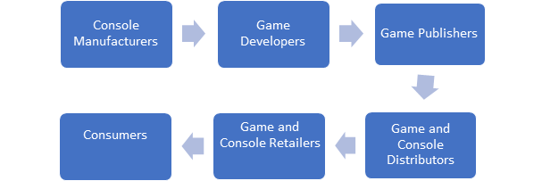

Previous Value Proposition

Due to the many intermediaries within the value chain, the traditional value proposition for the console makers and the game developers differed from today’s model. The console makers focused on delivering value through technologically superior devices to enhance gameplay quality and the game developers on delivering value through their games' entertainment and enjoyment. They both, however, still relied on the distributors and retailers to reach consumers. They couldn't provide much value on that end as the distribution of their games was primarily in the hands of retailers.

Current Value Proposition

The digital disruption in the gaming industry has allowed significant changes to occur for both console makers and game developers, and publishers. With the development of online game downloads, downloadable content, and subscription services, the need for game distributors and certain retailers is dwindling. With the console producers working in tandem with game developers and publishers to release their games electronically, they have changed the value proposition of the entire industry. No longer do consumers have to make the trip to retail stores to pick up hard copies of games. Now, consumers are afforded the ease of reviewing, selecting, and downloading games directly from their console. The ability to upgrade games and download additional content provides value to consumers who would like a more customized gaming experience. And lastly, the shift to electronic downloads creates value by eliminating the need for hard copies of games that are susceptible to damage.

The subscription models being offered by many console makers and game developers also deliver value by allowing consumers to pay a monthly rate for access to hundreds of games. This has done a lot to eliminate the cost of accessing multiple games through the traditional retail model, which required purchasing or renting each game separately.

**Technology as an enabler of digital disruption**

Technologies such as the internet, mobile, Internet Of Things (IoT), and cloud created extraordinary disruption. With these technologies, companies can get and serve more customers and improve and innovate the products and services.

**Technology platforms that enable the disruption**

Internet

The emergence of the internet has transformed the entire gaming industry. In the early days, when there was no internet, players needed to go to the game store to buy physical copies of games. With the popularity of high-speed internet, people do not need to purchase hard copies of games in game retail stores but can directly buy games in online stores or place orders online for home delivery. Moreover, most of the games nowadays are online games, allowing players worldwide to play together.

Portable devices

With the advent of mobile phones and tablet computers, games are no longer limited to computers and game consoles. People began to prefer to play games on mobile phones because it is more convenient to play games, and mobile games are more comfortable to operate and more friendly to novices.

Electronic products

Electronic products can process more sophisticated orders, and games are becoming more complex and exciting. From the original 2D game to the current 3D and VR games.

Enhanced gaming equipment

All previous games used the mouse and keyboard to control the character. Now, through voice recognition technology, people can control the movement of game characters by speaking commands. Also, motion sensors will capture our actions, and we can also move game characters through gestures to further increase the gaming experience. We can also customize the appearance of game characters using a 3D camera. Therefore, people have an immersive real game experience.

**Different ways in which these technology platforms enabled these digital disruptions to take place**

Online Video Streaming

Streaming and subscription services represent the fastest-growing segment of the Video Games industry. Game subscription services loosely follow the [Netflix](https://media.netflix.com/en/about-netflix) business model, largely predicated on unlimited access to a wide and expanding selection of titles. Given the longevity of this business model, supply chains are efficient and clear. However, as high-speed internet has become more accessible, the possibility of streaming video games has become more feasible.

#### On-Demand Gaming

Gamers can already watch and share live-streams of games, but what about playing them? Much like similar movie streaming services, the ability to stream video games is becoming more and more a reality, and it could lead game developers both big and small to compete for gaming glory.

Mobile Gaming

With the advent of smartphones, the gaming experience has been taken out of the arcade and the living room and put into the palm of your hand. As evidenced by the countless people on your morning train commute huddled over games on their devices, mobile technology has made the love of digital gaming spread beyond hardcore console-consumers and online gamers.

Tech powerhouses Google and Apple , though already tangentially involved in the industry through their operation of mobile game marketplaces on Android and iOS devices, respectively, are now building out subscription services that appeal to different types of gamers. Though both stores already have thousands of games to play, the majority are monetized through “free-to-play" mechanics, forcing players to watch ads or wait to progress (or else spend money to bypass these annoyances).

Gamer Analytics & Data Management

Most of the digital disruptors such as NVIDIA, Microsoft and others are using Gamer Analytics and Data Management for analyzing customer’s behavior by developing the mechanisms to acquire, aggregate, analyze and act on data received from gamers from within the game and outside of it.

Channel Management

Knowing where to place the game and how much to charge the gamer for it, and building the right relationships or in-house technologies to support the transactions.

Game Portfolio Management

Building the right game portfolio, knowing when to invest in new IP, when to gracefully retire maturing IP, and how to increase the returns on investment with successful brands.

Development Efficiency

As the pendulum swings away from pure artisan development to engineering diligence, there is an increased importance placed on being able to drive efficiencies that enable developers to be lean, and rapidly deliver quality results at scale.

Cloud Gaming

Bringing the best gaming experience to any platform, at any time, from anywhere requires expertise in cloud hosting and online streaming capabilities. Gamers will come to expect that their experience is seamlessly integrated across ubiquitous platforms.

Instead of creating video game systems that require more powerful hardware, developers are looking to lighten the load with the cloud. Games no longer need be limited by the amount of memory that discs or consoles have to offer. Using the cloud opens games up to massive server-size limits where images are streamed to your screen through the Internet.

Revenue Model Design

Incorporating monetization into the game design and development process from the beginning to create a seamless experience that optimizes gamer lifetime value.

## Customer Support

Determining the best approach for managing direct-to-consumer relationships, troubleshooting gamer issues and complaints, reducing gamer churn and preventing loss of gamer engagement.

## Facial Recognition

3D scanning and facial recognition technology allows systems to actually create your likeness in the gaming world (so you can create a custom avatar that looks just like you), or to inventively transfer your own expressions to other digital creations. On top of that, the Intel®RealSense™ 3D camera could allow developers to create games that adapt to the emotions of the gamer by scanning 78 different points on a person’s face. For example, a few grimaces at your game screen means the system would dial down the game’s difficulty instantly.

## Voice Recognition

Voice controlled gaming has been around for a while, but the potential of using the technology in gaming systems has finally caught up to reality—computers are now able to easily recognize voice commands from the user. Not only can you turn the console on and off using this tech, but you can also use voice commands to control gameplay, interact on social media, play selections from your media library, or search the web, all by simply talking to your gaming system.

#### Gesture Control

Intel RealSense technology allows you to play first person shooter games—or simply interact with your device—with just a few waves of your hand. Using a 3D camera that tracks 22 separate points in your hand, gesture control allows users to connect with their gaming experience by using the natural movements of your body. For example, the game Warrior Wave employs RealSense technology so you can use your hand (the outline of which shows up on the screen) to lead a group of Ancient Greek soldiers to safety.

## Virtual Reality

Though many virtual reality gaming consoles haven’t been commercially released as of yet, those developing VR headset displays are poised to grant gamers a fully immersive gaming experience the likes of which nobody has seen before. You’ll actually be able to lose yourself in the game before you come back to reality.

## Augmented Reality

If the virtual world isn’t your thing, why not try out some games in ours? Not confined to a TV or computer monitor, AR games allow for a perspective unique to the gamer. They maneuver spaces within the real world and make the object of the game applicable to real-life situations. For example, play table hockey on your kitchen counter from any angle, or partake in some puzzles mapped out via obstacles in your backyard.

## Wearable Gaming

Whether it’s smartwatches or glasses, wearable games make gaming portable without being too invasive. Companies that started by using wearable technology for fitness applications are now aiming to incorporate entertainment into the mix as well. Wearables aren’t only extensions of your body, but also extensions of the gaming consoles you know and love.

**Conclusion**

As game companies continue to be pressured by increasing consumer demands, the rise of digital endpoints and lower barriers to entry for low-cost alternatives, the need to innovate and join the revolution of disruptors is more critical than ever. Though there may always be a place for physical discs in games, the growth and influence of streaming and subscription services are likely to push the industry closer to an all-digital gaming ecosystem. Supported by continued growth in digital streaming revenue, the Video Games industry will continue its upward trajectory over the five years to 2024, with industry revenue growing an estimated annualized 8.7% to total $101.2 billion.

“There is an intrinsic value in allowing people to experiment a lot. In the short term it is probably not so efficient, but if you have this open and creative environment it is easier to attract talented people who value that. They can try out new tools and experiment, and that is a big part of our success.” (*Mats-Olov Eriksson*, Director of data warehousing, King.com)

**References/Sources**

11 Unbelievable Advances in Gaming Technology. (2021). Retrieved 2 March 2021, from https://www.mentalfloss.com/article/61764/11-unbelievable-advances-gaming-technology

GameStop 2019 Annual Report. (2019). Retrieved 1 March 2021, from https://news.gamestop.com/static-files/9d2139e1-31c7-498f-ad95-63db1e6d085a

Kelly, C., Mishra, B., & Jequinto, J. (2014). The Pulse of Gaming Gaming Disruption. Retrieved 4 March 2021, from <https://www.accenture.com/us-en/~/media/Accenture/Conversion-Assets/LandingPage/Documents/3/Accenture-3-LT-10-Pulse-Gaming-Disruption.pdf>

Lukasik, M. (2015). Sony PlayStation Now - evolution of gaming business models. Retrieved 1 March 2021, from https://www.hbs.edu/openforum/openforum.hbs.org/goto/challenge/understand-digital-transformation-of-business/sony-playstation-now-evolution-of-gaming-business-models.html

Luo, J. (2018). Rethinking the Video Game Business Model - Digital Innovation and Transformation. Retrieved 1 March 2021, from https://digital.hbs.edu/platform-digit/submission/rethinking-the-video-game-business-model/

Masters, N. (2019). Tech Disruption (Part 1) – Video Game Streaming Services | IBISWorld Industry Insider. Retrieved 3 March 2021, from <https://www.ibisworld.com/industry-insider/analyst-insights/tech-disruption-part-1-video-game-streaming-services-in-the-us/>

Perotta, M. (2020). Business Models of Video Games: Past, Present, and Future. Retrieved 4 March 2021, from https://medium.com/@mjperrotta46/business-models-of-video-games-past-present-and-future-2b2aafe8ade1

Savitz, E. (2019). GameStop Has Become the Poster Child for Retail Woes and Tech Disruption. Retrieved 27 February 2021, from https://www.barrons.com/articles/gamestop-stock-retail-ecommerce-risk-51559786806

Section F, T. (2017). Disruption of Video Game Retailers. Retrieved 1 March 2021, from https://digital.hbs.edu/platform-rctom/submission/disruption-of-video-game-retailers/

The 6 Trends Shaping the Future of Gaming & Digital Media. (2015). Retrieved 28 February 2021, from <https://newzoo.com/insights/articles/how-games-are-shaping-the-future-of-digital-and-broadcast-media/>

**Appendices**

## Exhibit A: Concise Income Statement of Gamestop, 2017-2019

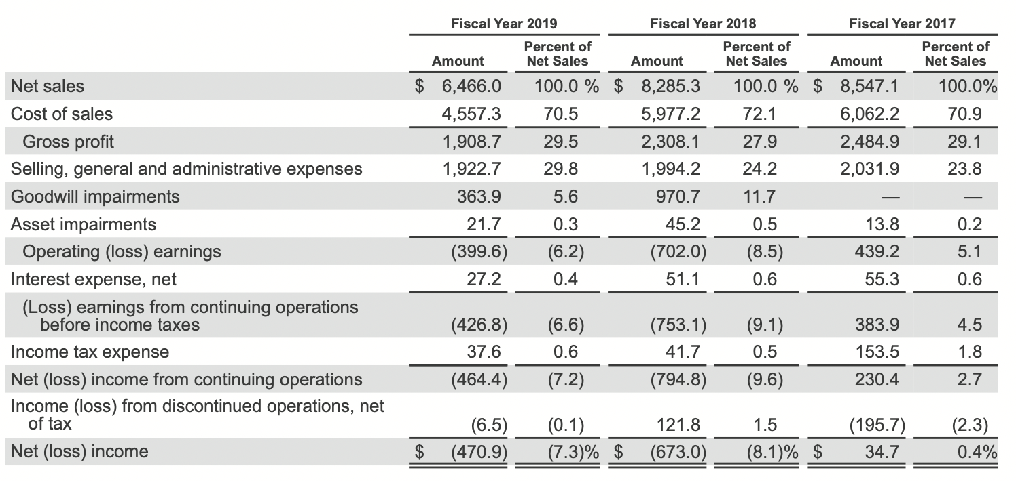

## Exhibit B: GME Stock Price 2015-2020

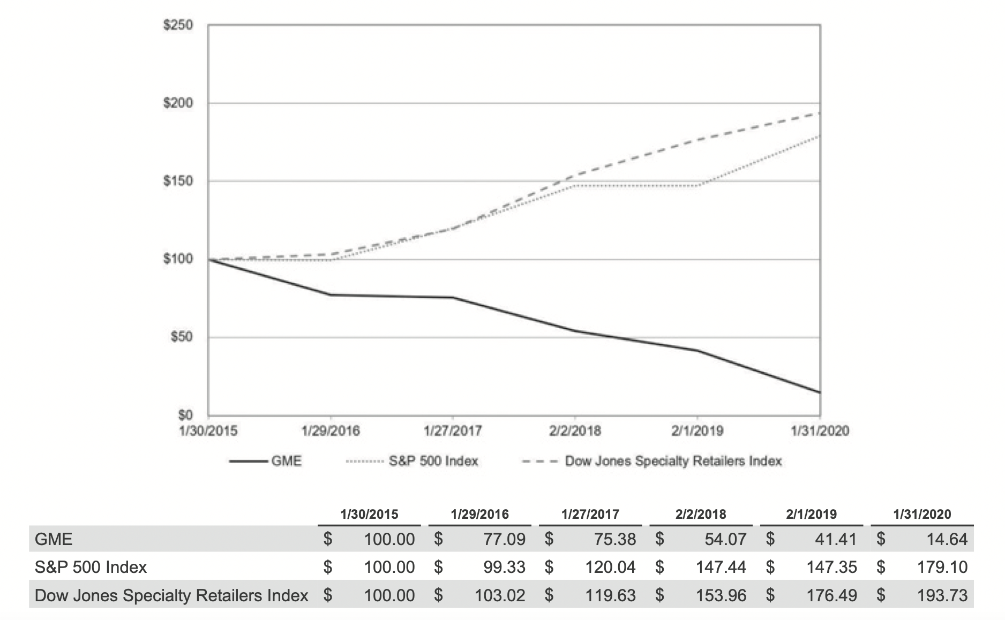

## 

## Exhibit C: US Gaming Marketing Statistics

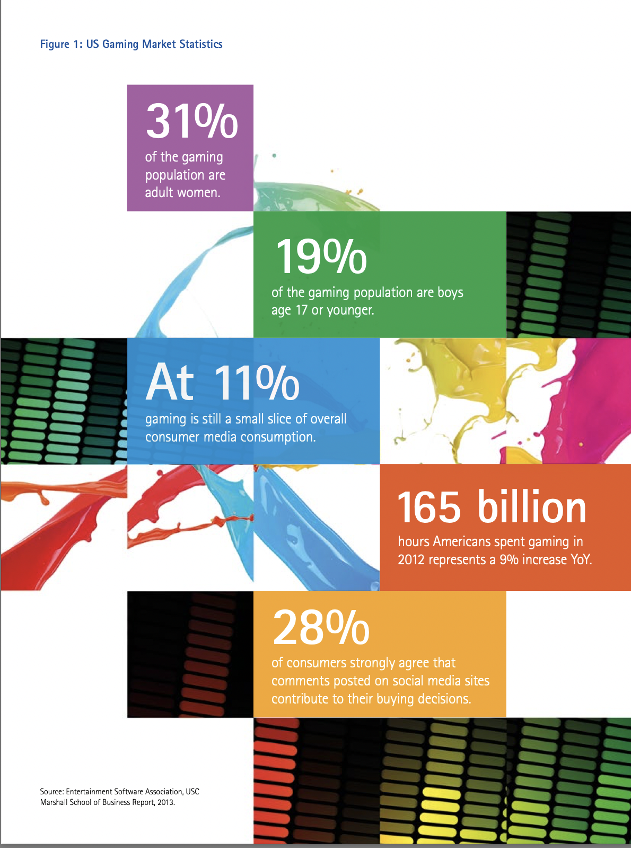

## Exhibit D: Game Industry Monetization Models

## Exhibit E: US Video Games Market Dynamics (2001-2025)

## 

Exhibit F: US Video Games Industry Major Players (2019)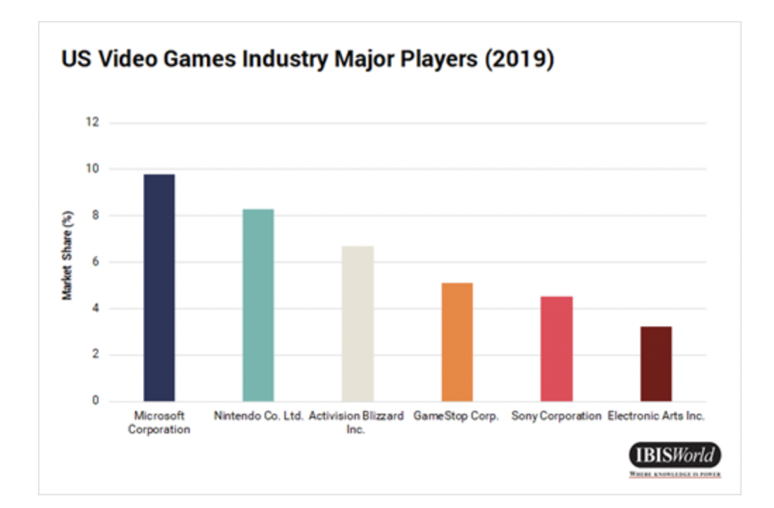

Exhibit G: 2016-2020 Global Games Market

